1. The number of colored words (list size) is an independent variable. Also the number of used colors is an independent variable. Because we choose them and manipulate them in the experiment.

The recorded time is a dependent variable. Because we measure it during the experiment.

1. I used two-tailed t-test: Ho=0 and Ha≠0. Because we suppose that a participant can read the same list of words using approximately the same time.

|  |  |
| --- | --- |
| Mean | -7.96 |
| Min | -21.919 |
| Q1 | -10.2585 |
| Median | -7.6665 |
| Q3 | -3.6455 |
| Max | -1.95 |

|  |
| --- |
| **SD of Differences** |
| **4.86** |

1. First is a histogram. Shows that we have negatively screwed distribution of the sample data. Also we can see that the mean is probably in the mode (-8.419; -5.719).

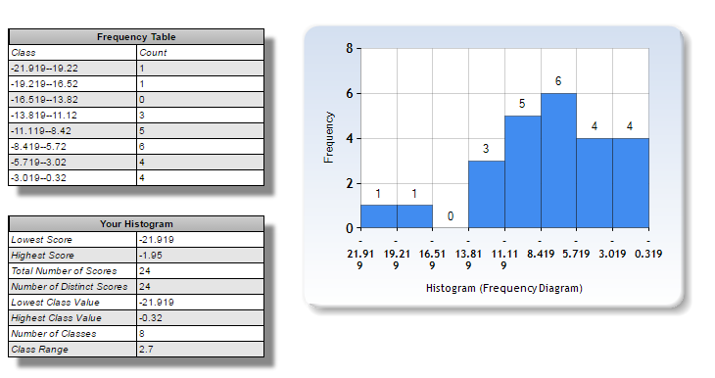

The second is a boxplot. Because it is a negatively screwed we assume that the mean is left of the median.

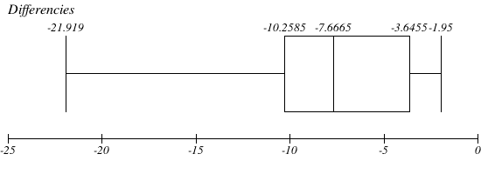

1. We have:

|  |
| --- |
| **n=24** |
| **df=n-1=23** |
| **α=0.05** |
| **t-critica l= +/- 2.069** |
|  |
| **Ho: μ 1=μ 2** |
| **Ha: μ 1≠μ 2** |

We got after the test:

|  |
| --- |
| **Mean or Point Estimate or Δμ** |
| **-7.96** |

|  |  |  |  |  |
| --- | --- | --- | --- | --- |
| **SD of Differences** | **t-statistic** | **Cohen's d** | **CI** | |
| **4.86** | **-8.02** | **-1.64** | **-10.02** | **-5.91** |

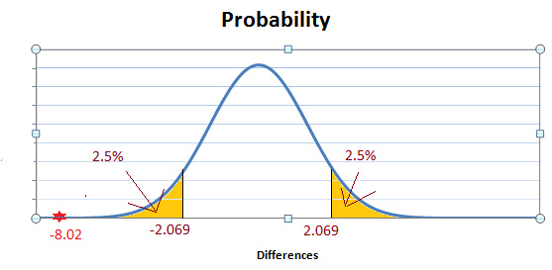

Here we see that t-statistic (-8.02) is much less than left t-critical (-2.069). What means that the probability to get the mean of sample -7.96 is in the left yellow zone, **μ 1<<μ 2.**

So we reject the Ho.

The result matches up my expectation because I knew about the Stroop effect.

1. My point is that the size of the list of colored words have the most effect to the measured time. A number of used colors has also significant effect. And off course it is critical that a participant has no idea about the Stroop effect.

There might be easier task: use only black, grey and white. I think it will show less differences of time.

1. The list of used resourses:

* The Lesson 10 “t-tests” of the current project.
* PDF files from the recourses tab of the project.
* <http://www.imathas.com/stattools/boxplot.html> for BoxPlot
* <http://www.socscistatistics.com/descriptive/histograms/> for Histagram
* MS Excel to draw the normal distribution of samples.